**Experiment No. 1**

**Aim:** To implement a Bluetooth network with application as transfer of a file from one device to another.

**Requirements:** Windows/MAC/Linux O.S, Compatible version of Android Studio and Android device to test the application.

**Theory:**

Bluetooth network is an application of wireless PAN (Personal Area Network). It is used to share data between two or more devices (advance in technology allowed connection of more than 2 devices through Bluetooth). It requires both party to make connection before transfer of data, one party shares the data and other party accept it if they want that data or they can reject it. Connection between parties terminated through forceful mean if one party disconnect or close the connection other party will automatically loose the connection.

It takes very low power and achieved it by embedded low-cost transceivers into the devices.  It supports the frequency band of 2.45GHz and can support up to 721KBps along with three voice channels. This frequency band has been set aside by international agreement for the use of industrial, scientific, and medical devices (ISM).rd-compatible with 1.0 devices.

It can connect up to “**eight devices”** simultaneously and each device offers a unique 48-bit address from the IEEE 802 standard with the connections being made a point to point or multipoint.

**Code:**

public class MainActivity extends AppCompatActivity {

//Create Objects-------------------------------------------------------

Button buttonopenDailog, buttonUp, send;

TextView textFolder;

EditText dataPath;

static final int CUSTOM_DIALOG_ID = 0;

ListView dialog_ListView;

File root, fileroot, curFolder;

private List<String> fileList = new ArrayList<String>();

private static final int DISCOVER_DURATION = 300;

private static final int REQUEST_BLU = 1;

BluetoothAdapter btAdatper = BluetoothAdapter.getDefaultAdapter();

//---------------------------------------------------------------

@Override

protected void onCreate(Bundle savedInstanceState) {

super.onCreate(savedInstanceState);

setContentView(R.layout.activity_main);

dataPath=(EditText)findViewById(R.id.FilePath);

buttonopenDailog= (Button) findViewById(R.id.opendailog);

send=(Button)findViewById(R.id.sendBtooth);

buttonopenDailog.setOnClickListener(new View.OnClickListener() {

@Override

public void onClick(View v) {

dataPath.setText("");

showDialog(CUSTOM_DIALOG_ID);

}

});

root = new File(Environment.getExternalStorageDirectory().getAbsolutePath());

curFolder = root;

send.setOnClickListener(new View.OnClickListener() {

@Override

public void onClick(View v) {

sendViaBluetooth();

}

});

}

@Override

protected Dialog onCreateDialog(int id) {

Dialog dialog = null;

switch (id) {

case CUSTOM_DIALOG_ID:

dialog = new Dialog(MainActivity.this);

dialog.setContentView(R.layout.dailoglayout);

dialog.setTitle("File Selector");

dialog.setCancelable(true);

dialog.setCanceledOnTouchOutside(true);

textFolder = (TextView) dialog.findViewById(R.id.folder);

buttonUp = (Button) dialog.findViewById(R.id.up);

buttonUp.setOnClickListener(new View.OnClickListener() {

@Override

public void onClick(View v) {

ListDir(curFolder.getParentFile());

}

});

dialog_ListView = (ListView) dialog.findViewById(R.id.dialoglist);

dialog_ListView.setOnItemClickListener(new AdapterView.OnItemClickListener() {

@Override

public void onItemClick(AdapterView<?> parent, View view, int position, long id) {

File selected = new File(fileList.get(position));

if (selected.isDirectory()) {

ListDir(selected);

} else if (selected.isFile()) {

getselectedFile(selected);

} else {

dismissDialog(CUSTOM_DIALOG_ID);

}

}

});

break;

}

return dialog;

}

@Override

protected void onPrepareDialog(int id, Dialog dialog) {

super.onPrepareDialog(id, dialog);

switch (id) {

case CUSTOM_DIALOG_ID:

ListDir(curFolder);

break;

}

}

public void getselectedFile(File f){

dataPath.setText(f.getAbsolutePath());

fileList.clear();

dismissDialog(CUSTOM_DIALOG_ID);

}

public void ListDir(File f) {

if (f.equals(root)) {

buttonUp.setEnabled(false);

} else {

buttonUp.setEnabled(true);

}

curFolder = f;

textFolder.setText(f.getAbsolutePath());

dataPath.setText(f.getAbsolutePath());

File[] files = f.listFiles();

fileList.clear();

for (File file : files) {

fileList.add(file.getPath());

}

ArrayAdapter<String> directoryList = new ArrayAdapter<String>(this, android.R.layout.simple_list_item_1, fileList);

dialog_ListView.setAdapter(directoryList);

}

//exit to application---------------------------------------------------------------------------

public void exit(View V) {

btAdatper.disable();

Toast.makeText(this,"*** Now Bluetooth is off... Thanks. ***",Toast.LENGTH_LONG).show();

finish(); }

//Method for send file via bluetooth------------------------------------------------------------

public void sendViaBluetooth() {

if(!dataPath.equals(null)){

if (btAdatper == null) {

Toast.makeText(this, "Device not support bluetooth", Toast.LENGTH_LONG).show();

} else {

enableBluetooth();

}

}else{

Toast.makeText(this,"Please select a file.",Toast.LENGTH_LONG).show();

}

}

public void enableBluetooth() {

Intent discoveryIntent = new Intent(BluetoothAdapter.ACTION_REQUEST_DISCOVERABLE);

discoveryIntent.putExtra(BluetoothAdapter.EXTRA_DISCOVERABLE_DURATION, DISCOVER_DURATION);

startActivityForResult(discoveryIntent, REQUEST_BLU);

}

//Override method for sending data via bluetooth availability--------------------------

@Override

protected void onActivityResult(int requestCode, int resultCode, Intent data) {

if (resultCode == DISCOVER_DURATION && requestCode == REQUEST_BLU) {

Intent i = new Intent();

i.setAction(Intent.ACTION_SEND);

i.setType("*/*");

File file = new File(dataPath.getText().toString());

i.putExtra(Intent.EXTRA_STREAM, Uri.fromFile(file));

PackageManager pm = getPackageManager();

List<ResolveInfo> list = pm.queryIntentActivities(i, 0);

if (list.size() > 0) {

String packageName = null;

String className = null;

boolean found = false;

for (ResolveInfo info : list) {

packageName = info.activityInfo.packageName;

if (packageName.equals("com.android.bluetooth")) {

className = info.activityInfo.name;

found = true;

break;

}

}

//CHECK BLUETOOTH available or not------------------------------------------------

if (!found) {

Toast.makeText(this, "Bluetooth not been found", Toast.LENGTH_LONG).show();

} else {

i.setClassName(packageName, className);

startActivity(i);

}

}

} else {

Toast.makeText(this, "Bluetooth is cancelled", Toast.LENGTH_LONG).show();

}

}

@Override

public boolean onCreateOptionsMenu(Menu menu) {

// Inflate the menu; this adds items to the action bar if it is present.

getMenuInflater().inflate(R.menu.menu_main, menu);

return true;

}

@Override

public boolean onOptionsItemSelected(MenuItem item) {

// Handle action bar item clicks here. The action bar will

// automatically handle clicks on the Home/Up button, so long

// as you specify a parent activity in AndroidManifest.xml.

int id = item.getItemId();

//noinspection SimplifiableIfStatement

if (id == R.id.action_settings) {

Toast.makeText(this, "****************\nDeveloper: Santosh Kumar Singh\nContact: superssingh@gmail.com\n****************", Toast.LENGTH_LONG).show();

return true;

}

return super.onOptionsItemSelected(item);

}

}

**Output:**

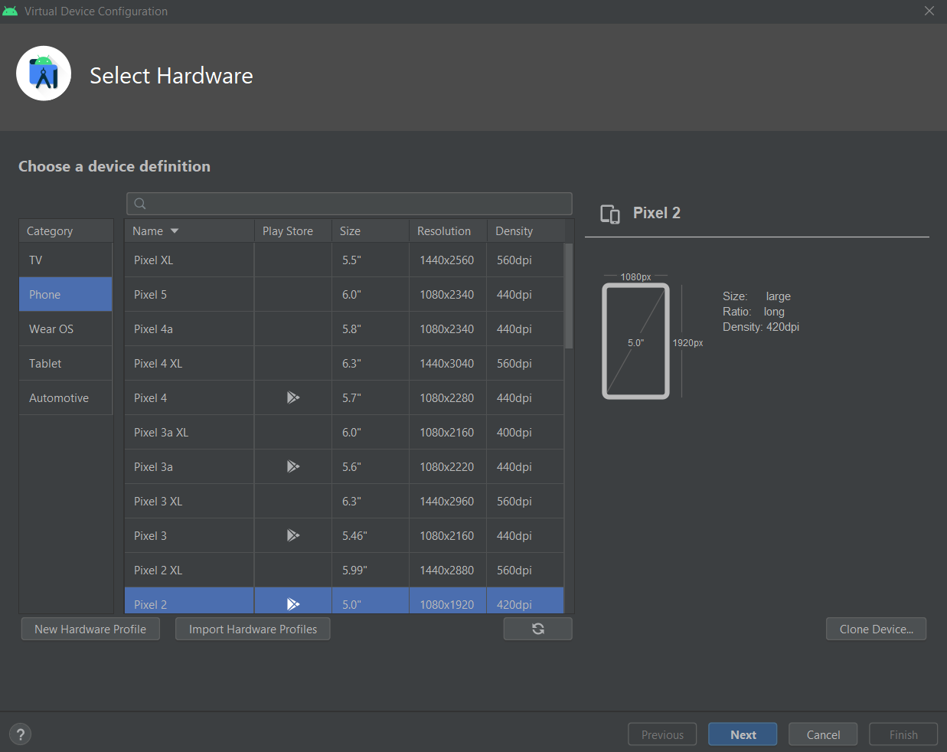

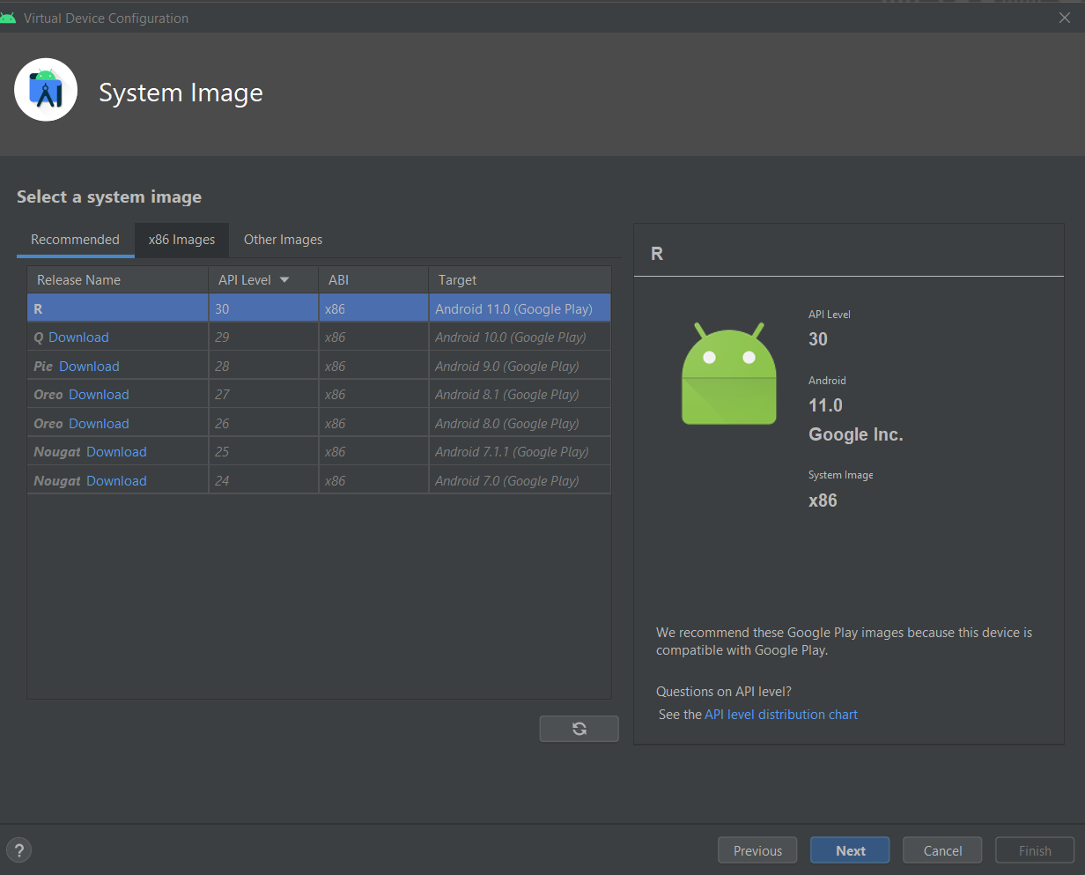

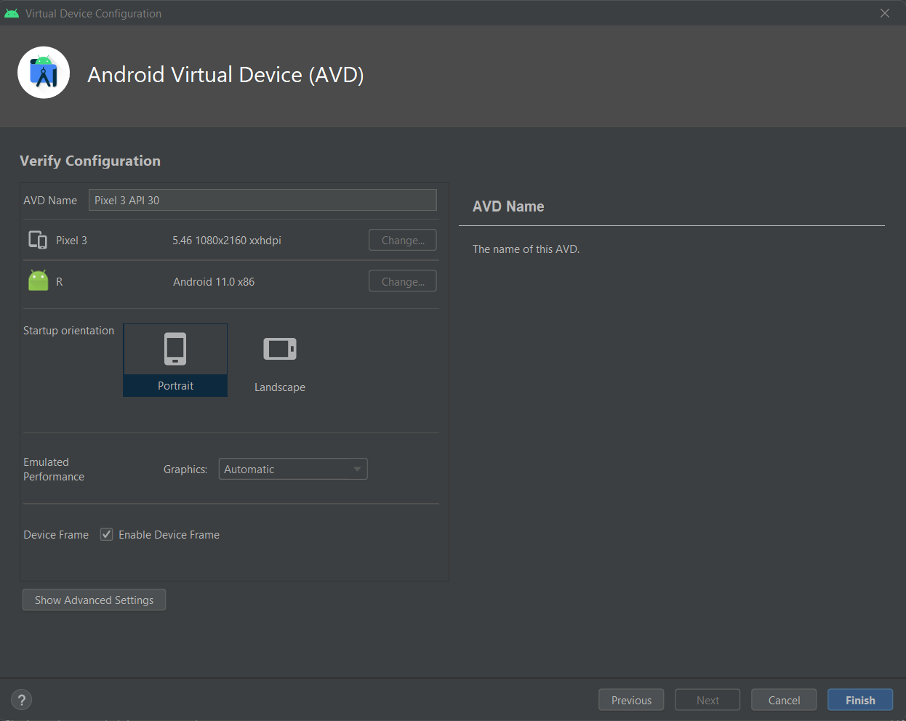

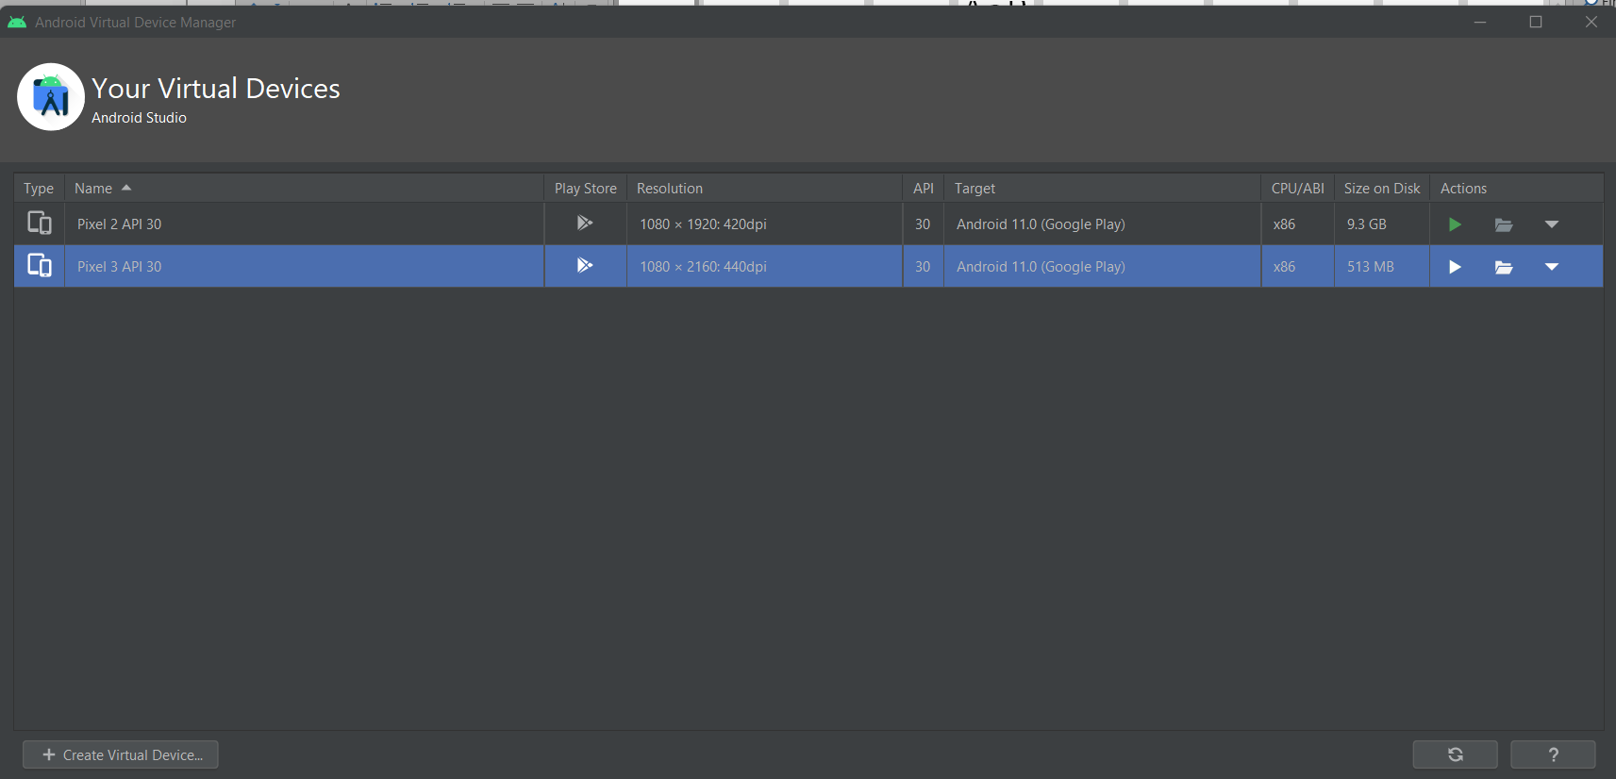

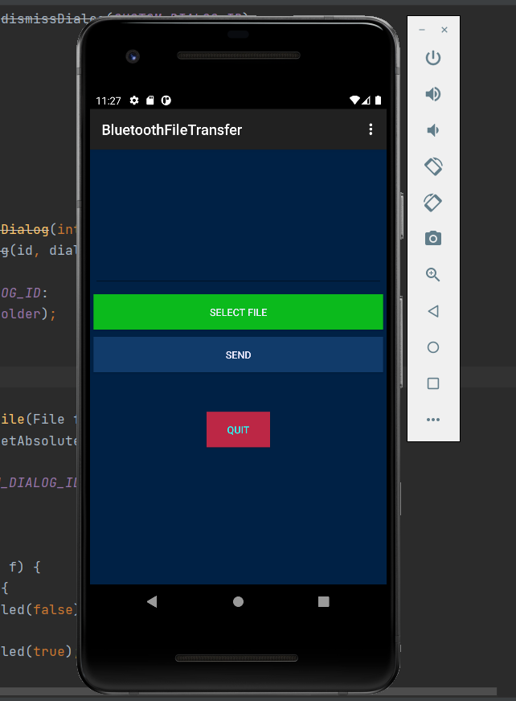 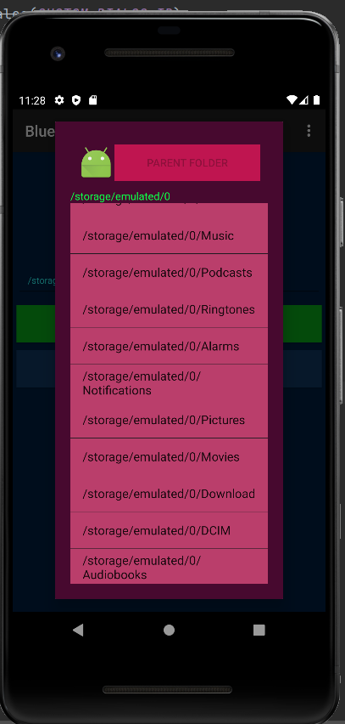 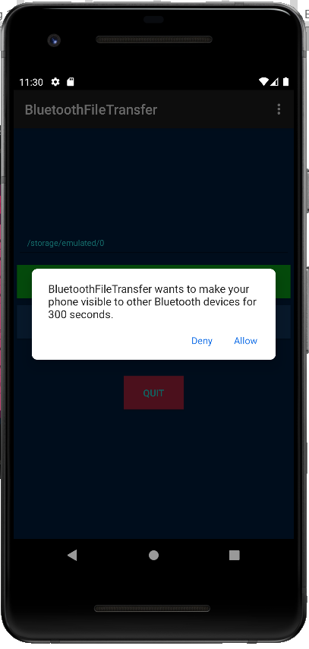

**Conclusion:** We have successfully implemented Bluetooth network with application in Android Studio using Java and tested the application using virtual devices presents in Android Studio.